Reinebringen is closed

Due to further construction of the path, Reinebringen is closed from 4’th of june until approximately 14’th of july.
Reinebringen har becomed well known amoung our tourists, and this has led to a hike that is in great need of repair. Terrain and weather conditions are reasons that this need to be done during the summerseason, when we have most visitors.
The work will be done by 8 employee from Stibyggjaren AS. They are specialists in this kind of work, and they are from Nepal.
It is necessary to close the mountain in order to secure our workers, and we hope you all understand the importance of this, and that you will respect this.
We apologize for the inconveniences, and will remind you that it is a lot of other nice hikes in Lofoten.

Executing Contractor | Action holder and builder
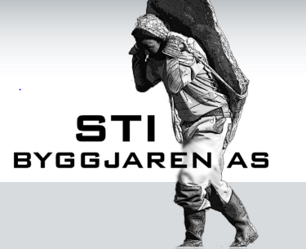 | Moskenes Municipality

- For more info of the project, call 0047 76053100
- Updated news are to be found at facebook, Reinebringen or Moskenes kommune,(municipality), facebookpage.

